PROJECT REPORT TEMPLATE

**1 OVERVIEW**

1.INTRODUCTION:

The title of the project allotted to our group is JOB APPLICATION TRACKING SYSTEM. Create a CRM Application which helps the applicant to track the No. of jobs he applied and helps him to find the job posted by the various recruiters, find the best attributes to be involved to run the process in a smooth way and easily to track

1.2 PURPOSE:

An ATS creates opportunities to automate manual processes, increase visibility into the hiring cycle for the entire recruiting team, and increase opportunities for communication throughout the candidate journey. 78% of recruiters using an ATS report that it has improved the quality of the candidates they hire.

**2 PROBLEM DEFINING AND DESIGN THINKING**

2.1 Empathy map 2.2 Ideation and Brainstorming map

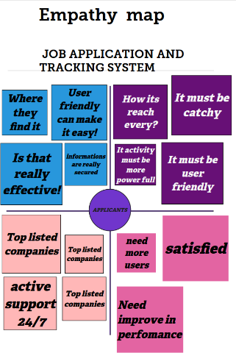

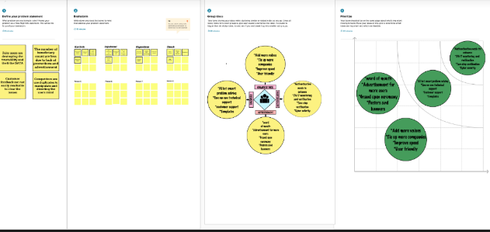

3 RESULT

3.1 Data Model:

|  |  |  |  |  |  |
| --- | --- | --- | --- | --- | --- |
| OBJECTS: | Recruiter | Jobs | Candidate | Job Application ……object | Tab |
| FIELD 1 | Field name | Field name | Field name | Field name | Field related |
| FIELD 2 | Data type | Length | Designation | Picklist | Style |
| FIELD 3 | Field label | Object related | Data type | Data type | Data type |
| FIELD 4 | Relation | Custom tab | Master-relation | Master-relation | Reports |

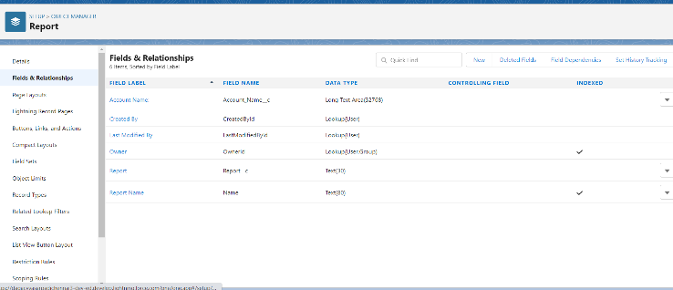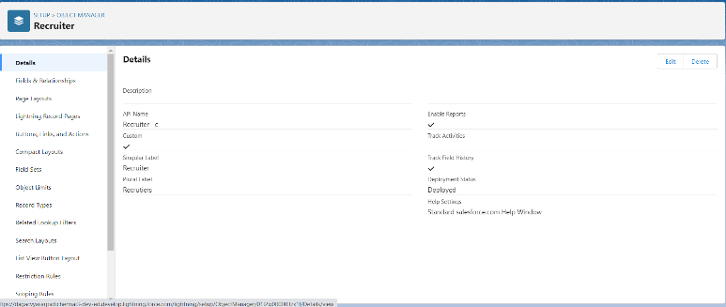

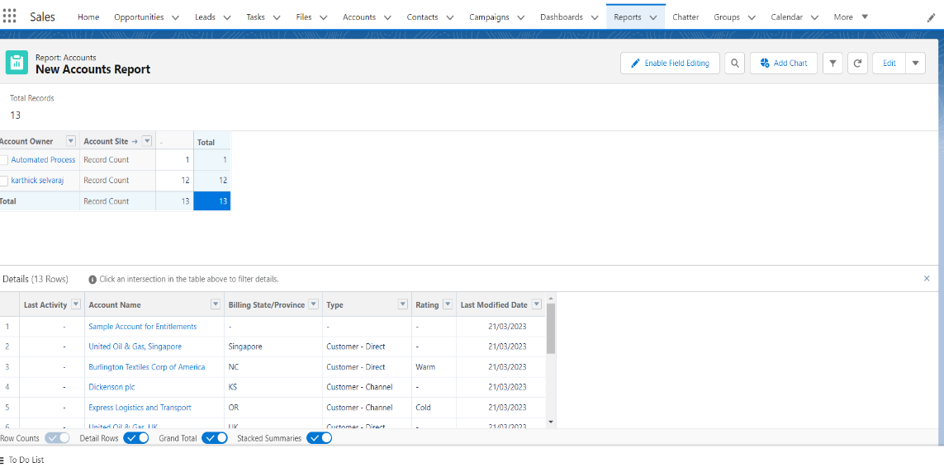

**4 Trailhead profile public URL:**

|  |  |
| --- | --- |
| **Team Lead:** | [**https://trailblazer.me/id/kselvaraj50**](https://trailblazer.me/id/kselvaraj50) |
| **Team Member 1:** | [**https://trailblazer.me/id/nagendiran**](https://trailblazer.me/id/nagendiran) |
| **Team Member 2:** | [**https://trailblazer.me/id/jaya88**](https://trailblazer.me/id/jaya88) |
| **Team Member 3:** | [**https://trailblazer.me/id/dinesh05**](https://trailblazer.me/id/dinesh05) |

**5 Advantages and Disadvantages:**

|  |  |
| --- | --- |
| **Saves Time for Value Added Work.** | * **A Disadvantage of ATS is missing qualified applicants due to wrong keyword selection.** |
| **Flexible System for Both Employer & the Agency** | * **Automatic elimination of every resume (even great ones) that the system can't read and interpret.** |
| **Better Overview of Applications.** | **They are open to manipulation.** |
| **Enabling  you to focus more on tasks that truly require your attention** | **Incorrectly categorized data from resumes that were created in an unusual format** |
| **Improved Quality of Hire.** | **particularly when recruiters rely solely on the tools for narrowing down applicants** |
| * **Faster & Better Decisions.** | * **Misread resumes in PDF format.** |

**6 Applications:**

**An ATS creates opportunities to automate manual processes, increase visibility into the hiring cycle for the entire recruiting team, and increase opportunities for communication throughout the candidate journey. 78% of recruiters using an ATS report that it has improved the quality of the candidates they hire.**

**7 Conclusion:**

A CRM Application which helps the applicant to track the No. of jobs he applied and helps him to find the job posted by the various recruiters, find the best attributes to be involved to run the process in a smooth way and easily to track.

**8 Future Scope:**

According to a recently released survey report, the majority of staffing firms worldwide will opt for an Applicant Tracking System by the end of 2020 to improve the overall talent acquisition efficacy, in this scope the future of ATS definitely looks bright.